ELEC4543 Assignment 5
Fuzzy System Design of Learning-from-Examples solving trucker problem

Name: Wang Yuli(Rainy)
U.no: 3035028946
Program: BEng(ElecE), Year5

Introduction
This assignment aims at using the Learning-from-Examples Approach to design a fuzzy system for the truck backer-upper problem as included in lecture notes (p. 12-7). To focus on model design & evaluation of the accuracy, we only need to provide sufficient sample data points to do the analysis. In the process, we need to choose initial position of the car and park the car manually, in order to generate sufficient data samples. Then we implement a fuzzy system accordingly and assess the performance. Performance of certain point depends on how we drive the car in the sample runs.

Following part of this report shows the specifics of the approach used, as well as evaluation on the final results. The content is organized in the sequence of how the experiment is conducted.

Implementation
Stage 1: Initial positions for the car

From problem description, we know the car is driven by:
park([ x y phi ], 'iodata')
where y is actually irrelevant, $x∈\left[-20, 20\right], ϕ∈[-180, 180]$

Hence, in order to generate sufficient input-output data for building the fuzzy system, define crisp sets:
$$x∈A= \left\{-20, -10, 0, 10, 20\right\},$$
$$ϕ∈B= \left\{-180, -120, -60, 10, 60, 120, 180\right\}$$

Therefore, we can construct fuzzy sets based on A & B. It also implies that we need 35 fuzzy inference rules as our fuzzy rule base. So we need to do 35 times of the parking to generate sufficient input-output pairs

Stage 2: Parking and save example data (parking strategy)

The parking strategy we use here is same as the common way taught by driving coaches. Take the following graph for an example:
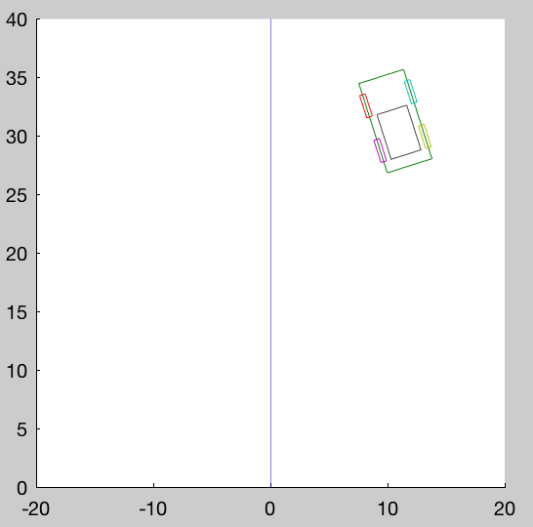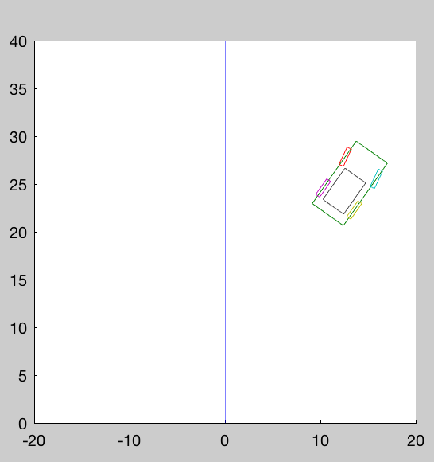

The strategy consists 4 parts:
- We will first turn the wheel to left in order for the car to rotate, so that its tail has a larger velocity moving towards the line in the middle. (as shown in the figure on LHS above)
- When we successfully moving it towards the line. (as shown in figure on RHS) we move in straight line
- But when we are close to the line, we then turn the wheel to right in order to make our orientation right
- If the car is placed on the line and with correct orientation, we move straight toward point (0,0).

After 35 times of parking, we now can generate our fuzzy system and start parking automatically.

Results

- Inference Rule look-up table
$$θ$$ | A1 | A2 | A3 | A4 | A5
B1 | C4 | C5 | C2 | C4 | C1
B2 | C5 | C2 | C1 | C4 | C1
B3 | C4 | C1 | C1 | C4 | C4
B4 | C1 | C1 | C4 | C6 | C4
B5 | C4 | C4 | C5 | C7 | C5
B6 | C7 | C7 | C7 | C4 | C3
B7 | C7 | C5 | C4 | C4 | C1

- Member functions

- Fuzzy system surface

- Testing & evaluation

Testing on a sample data set:

Perform auto-parking using the following testing dataset:
Success(0/1) | $$x=-15$$ | $$x=-5$$ | $$x=5$$ | $$x=15$$
$$ϕ= -150$$ | 0 | 0 | 1 | 1
$$ϕ= -100$$ | 0 | 0 | 1 | 1
$$ϕ= -30$$ | 0 | 1 | 1 | 0
$$ϕ= 30$$ | 0 | 1 | 1 | 1
$$ϕ= 100$$ | 1 | 1 | 1 | 0
$$ϕ= 150$$ | 1 | 1 | 0 | 0

Accuracy: 58.3%

Evaluation of the results:
The overall accuracy is much lower than expected. The cases when $x$ or $ϕ$ are both far from 0, witnessed worse performance. This could be because of the demonstration step (i.e. stage 2 of the implementation).

Our strategy of parking is not perfect, because it lacks a way to differentiate a point far from the origin. For example, in the experiment, I only use rotation degrees about maximum 30 in all cases, just because 40 is really hard to control. However, without utilize the full range of $ϕ$ (i.e. [-40, 40]), we waste space over the output fuzzy sets. This is also why our inference lookup table are filled with more 4s & 5s than 1s & 7s.

To improve the performance, one possible way can be changing the demonstration strategy, so that we are always changing $θ$ for different $x$ and $ϕ$. Meanwhile, we should also pay attention to use larger $θ$ for $x$ and $ϕ$ far from point (0,0) and vice versa.

Conclusion
To design a fuzzy system using learn-from-examples approach, we should be very careful in generating the input-output pairs. Not only should we consider use uniformly distributed inputs over the given range, we should also pay special attention to the intuitive differences between different inputs, and perform the experiment in slightly different ways.

